

Course Code: CBS3005
Course Title: Cloud, Microservices and Applications
Class Number: VL2025260105679
Lab Assessment - 1
Name: Atharva Khachane
Reg No: 22BBS0155

Q.1) Create and manage EC2 instances on AWS. Launch an application on an EC2 instance in one region and then migrate that instance to another region. Additionally, set up another EC2 instance to install MySQL, create a database (e.g., student or employee database), and perform basic SQL operations.
Solution:
- Initial EC2 Page:
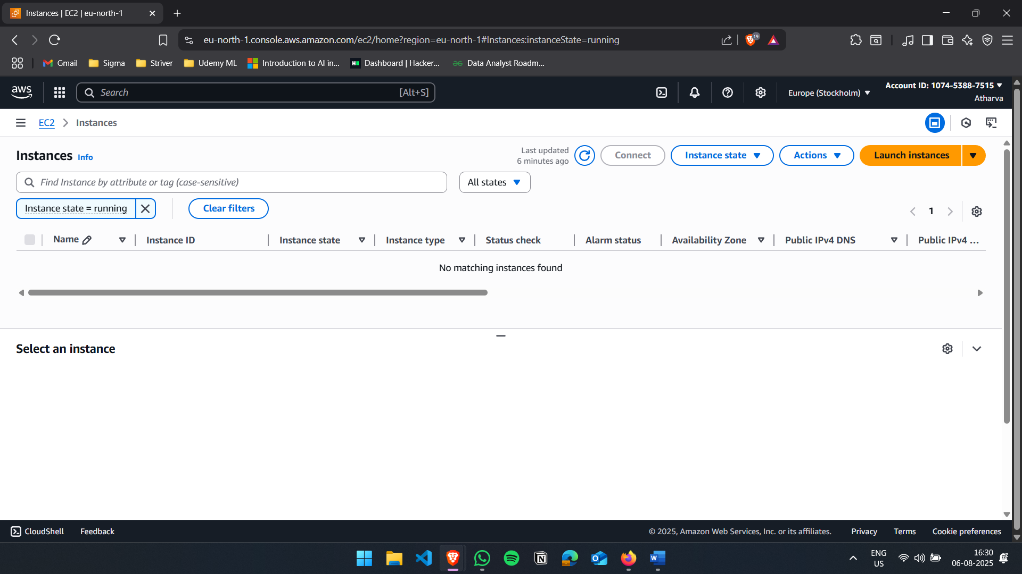

- First EC2 Creation:
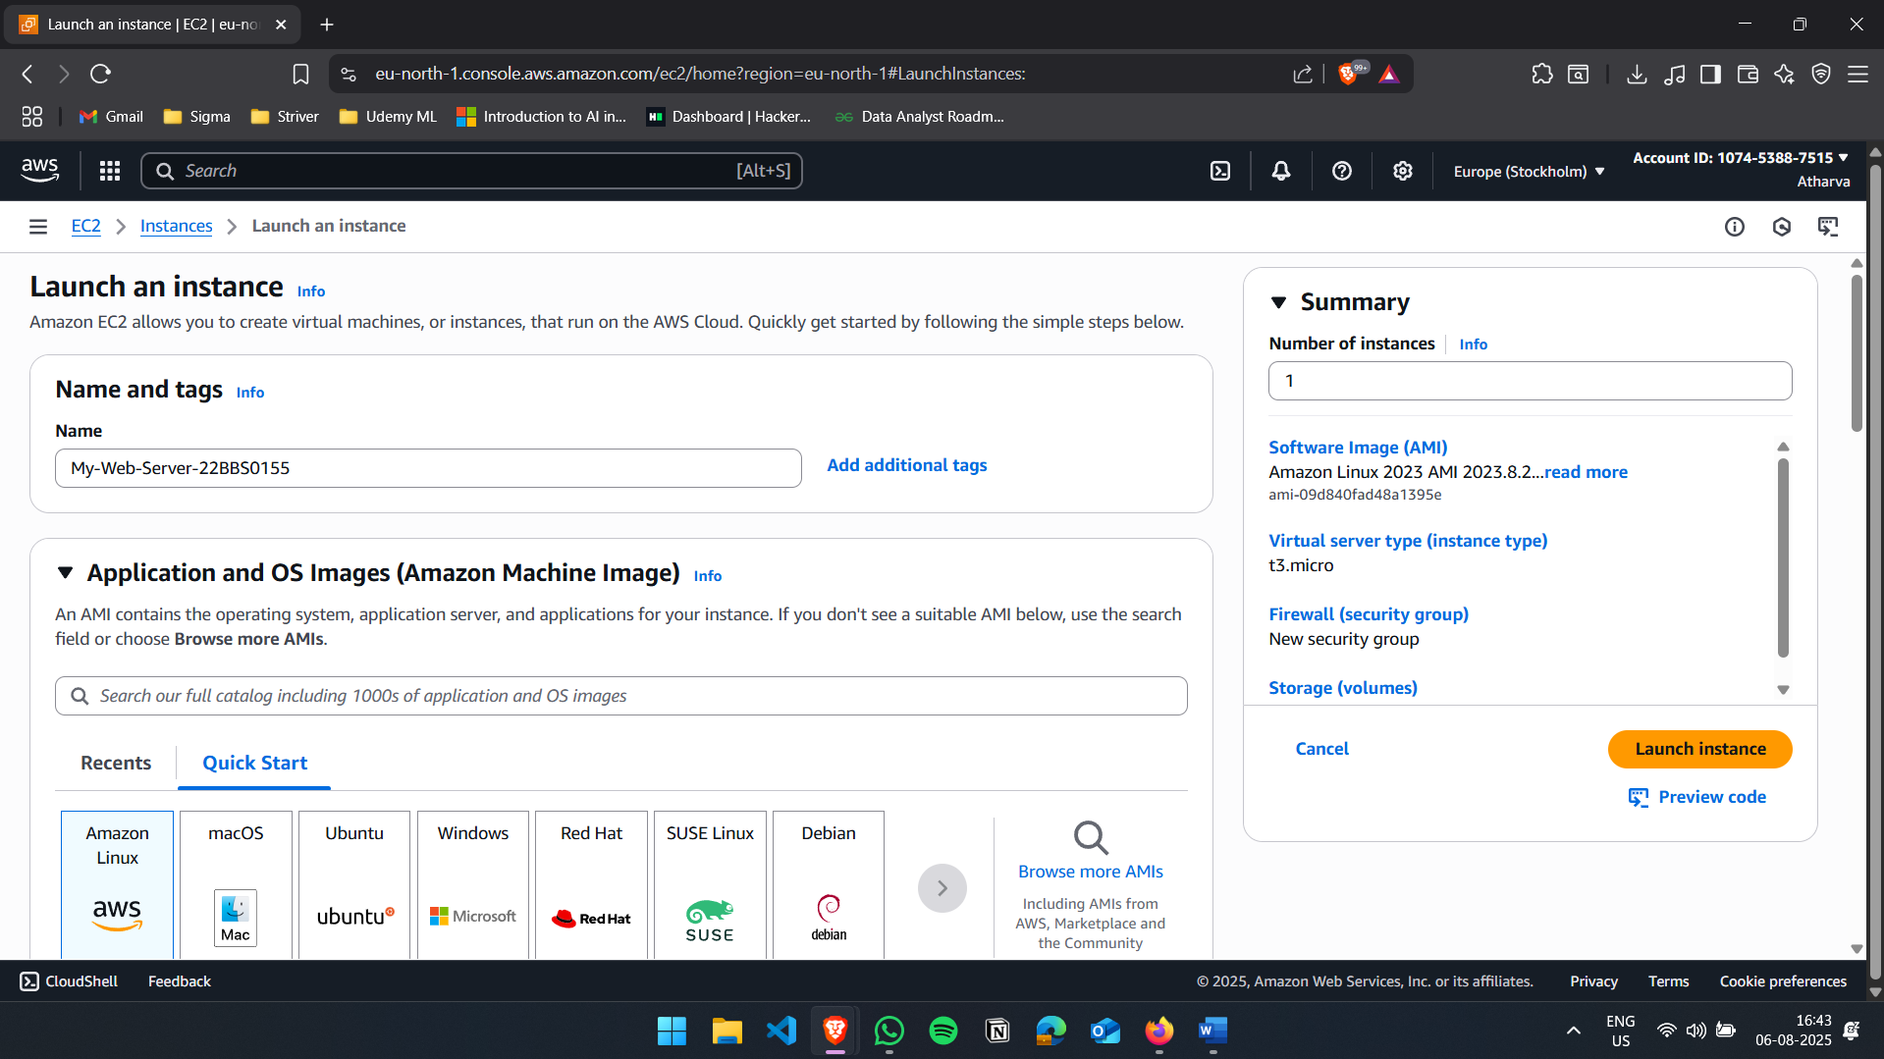
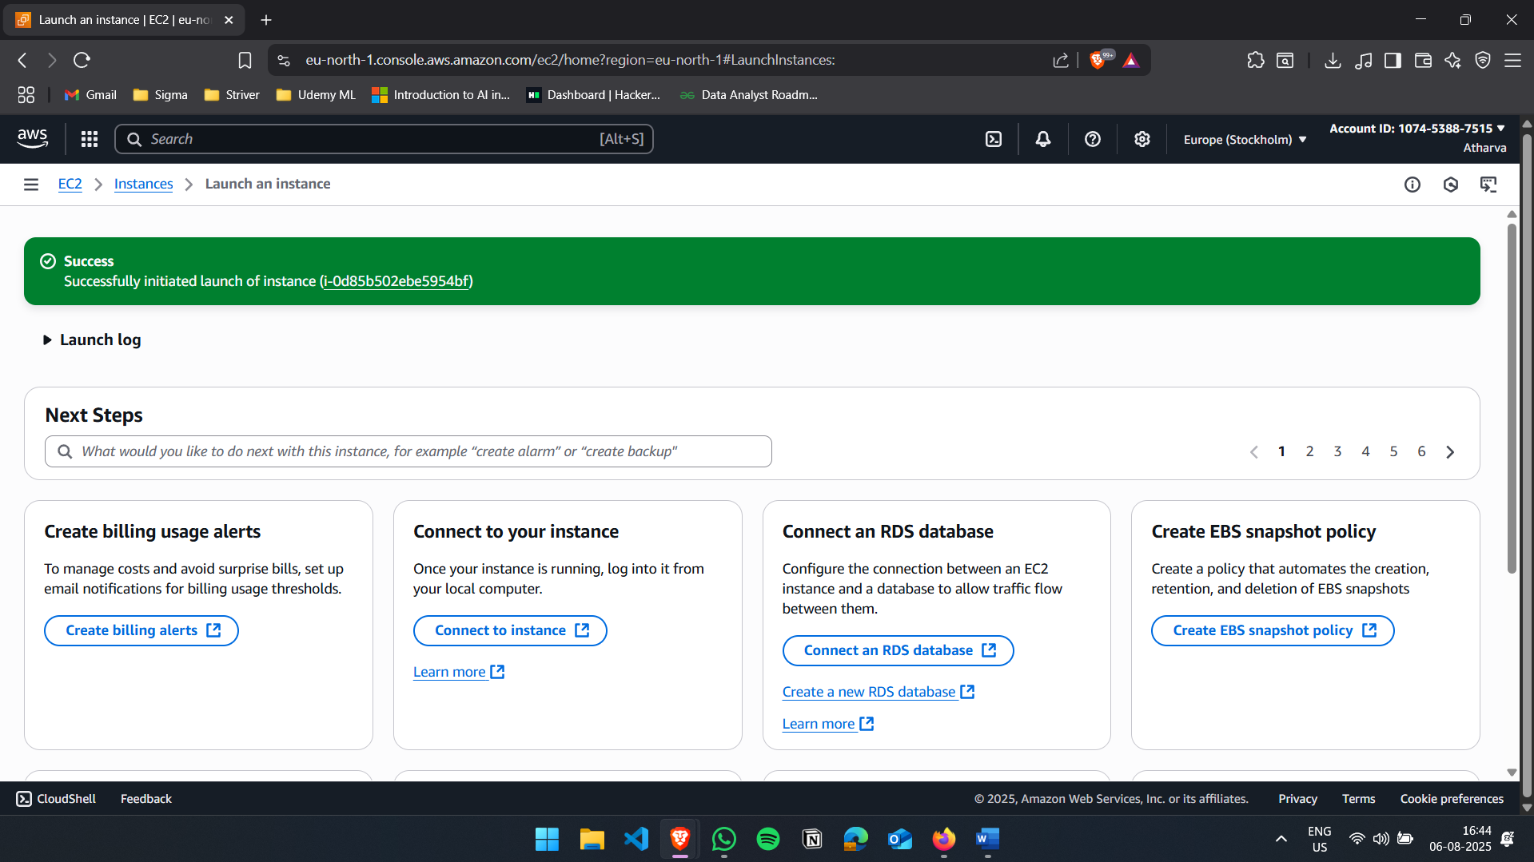

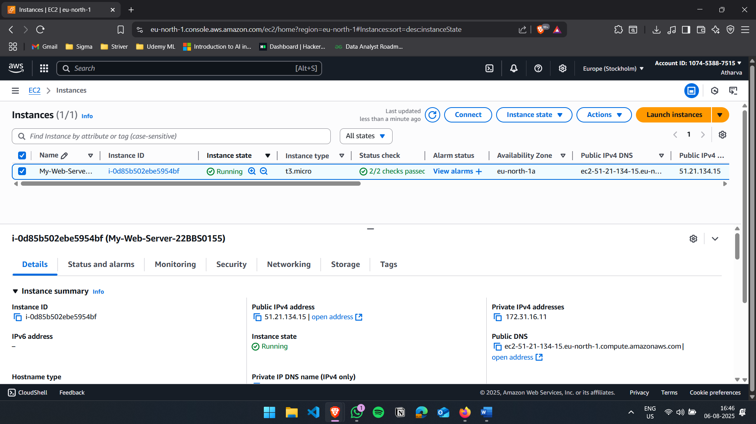

- Create AMI of the Instance
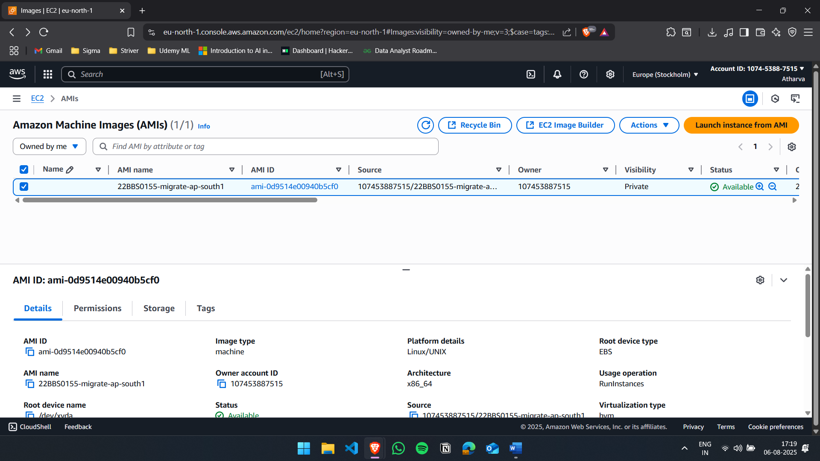

- Copy AMI and Change the Destination to Mumbai
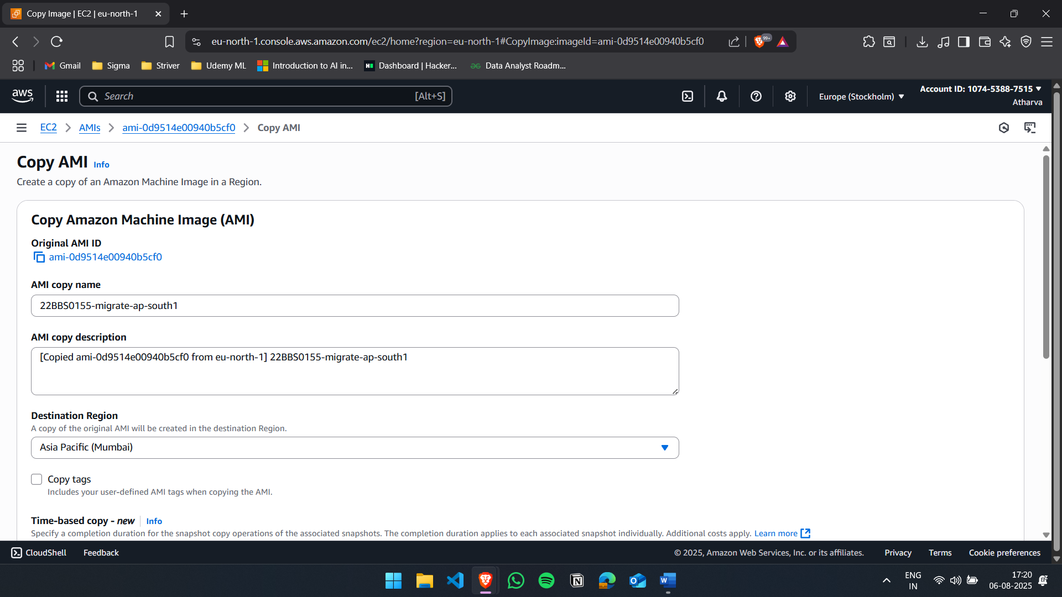

- Change the region to Mumbai
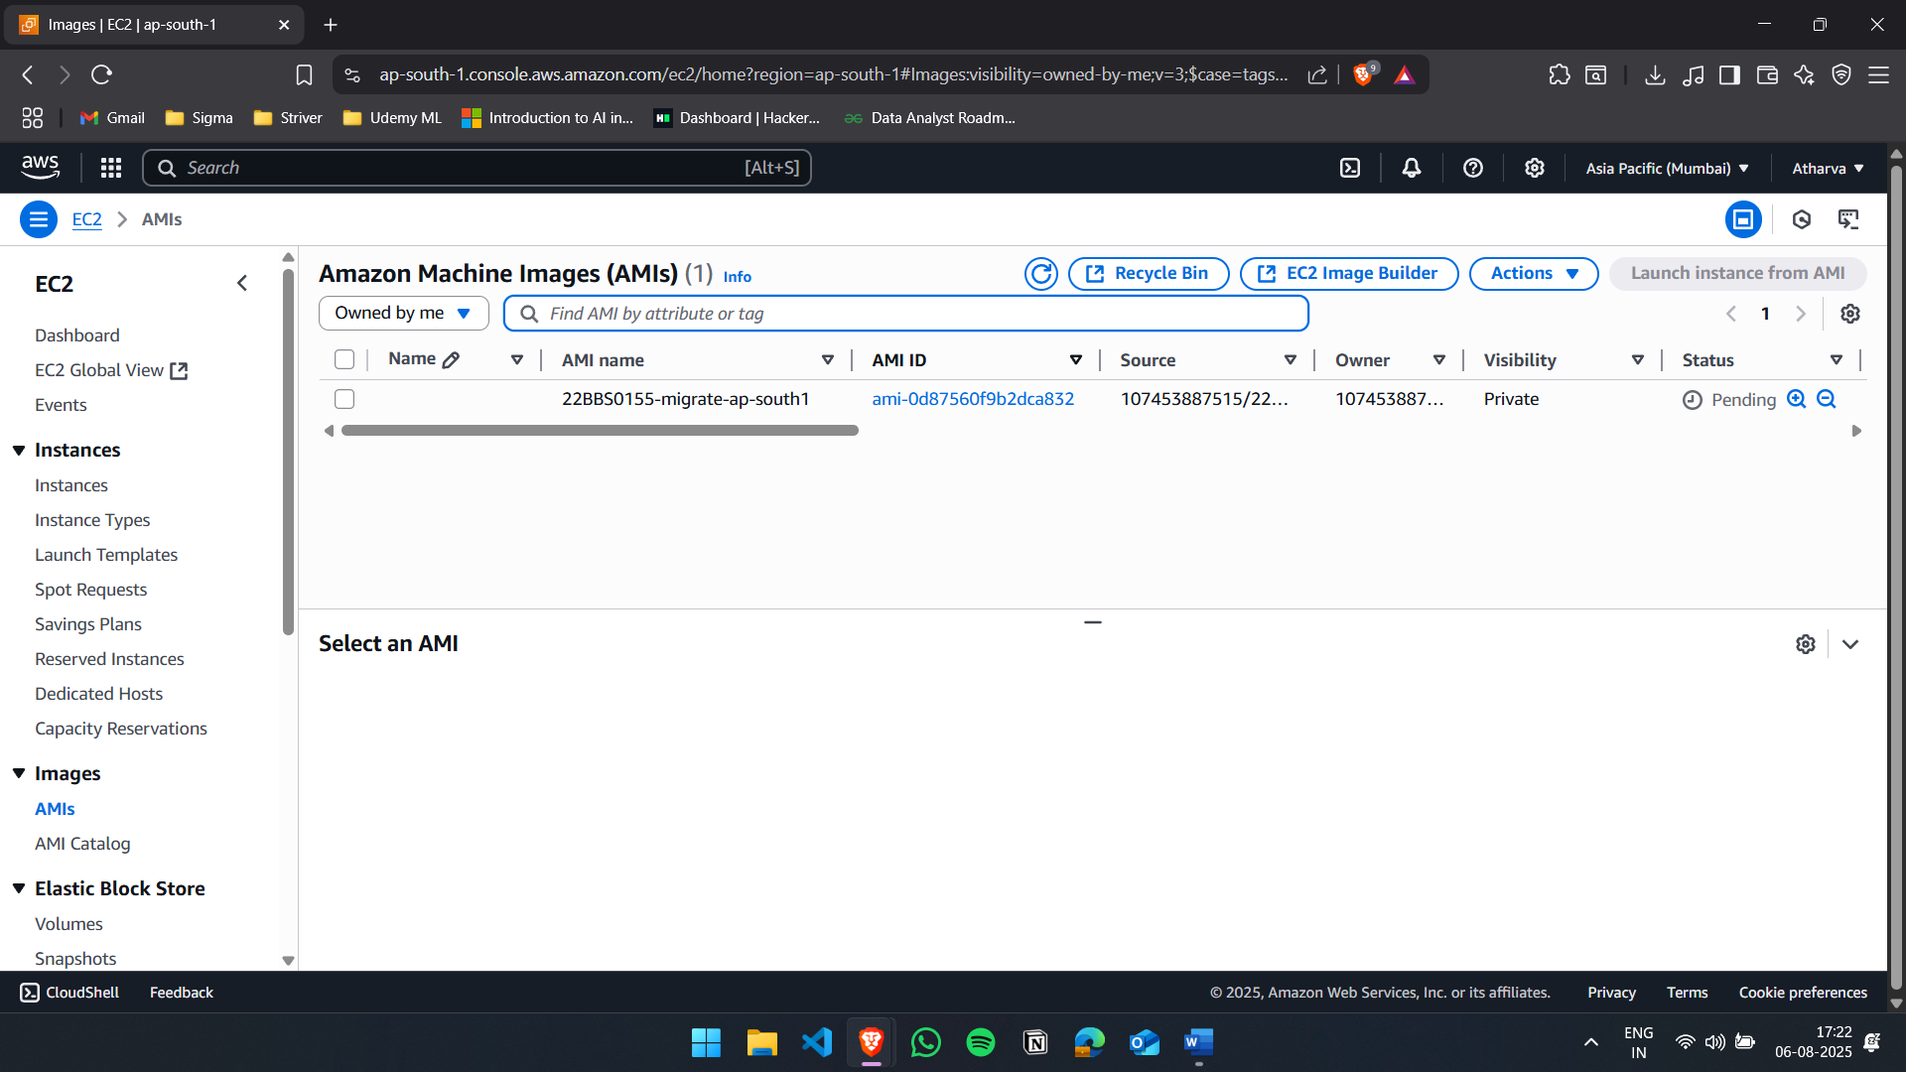

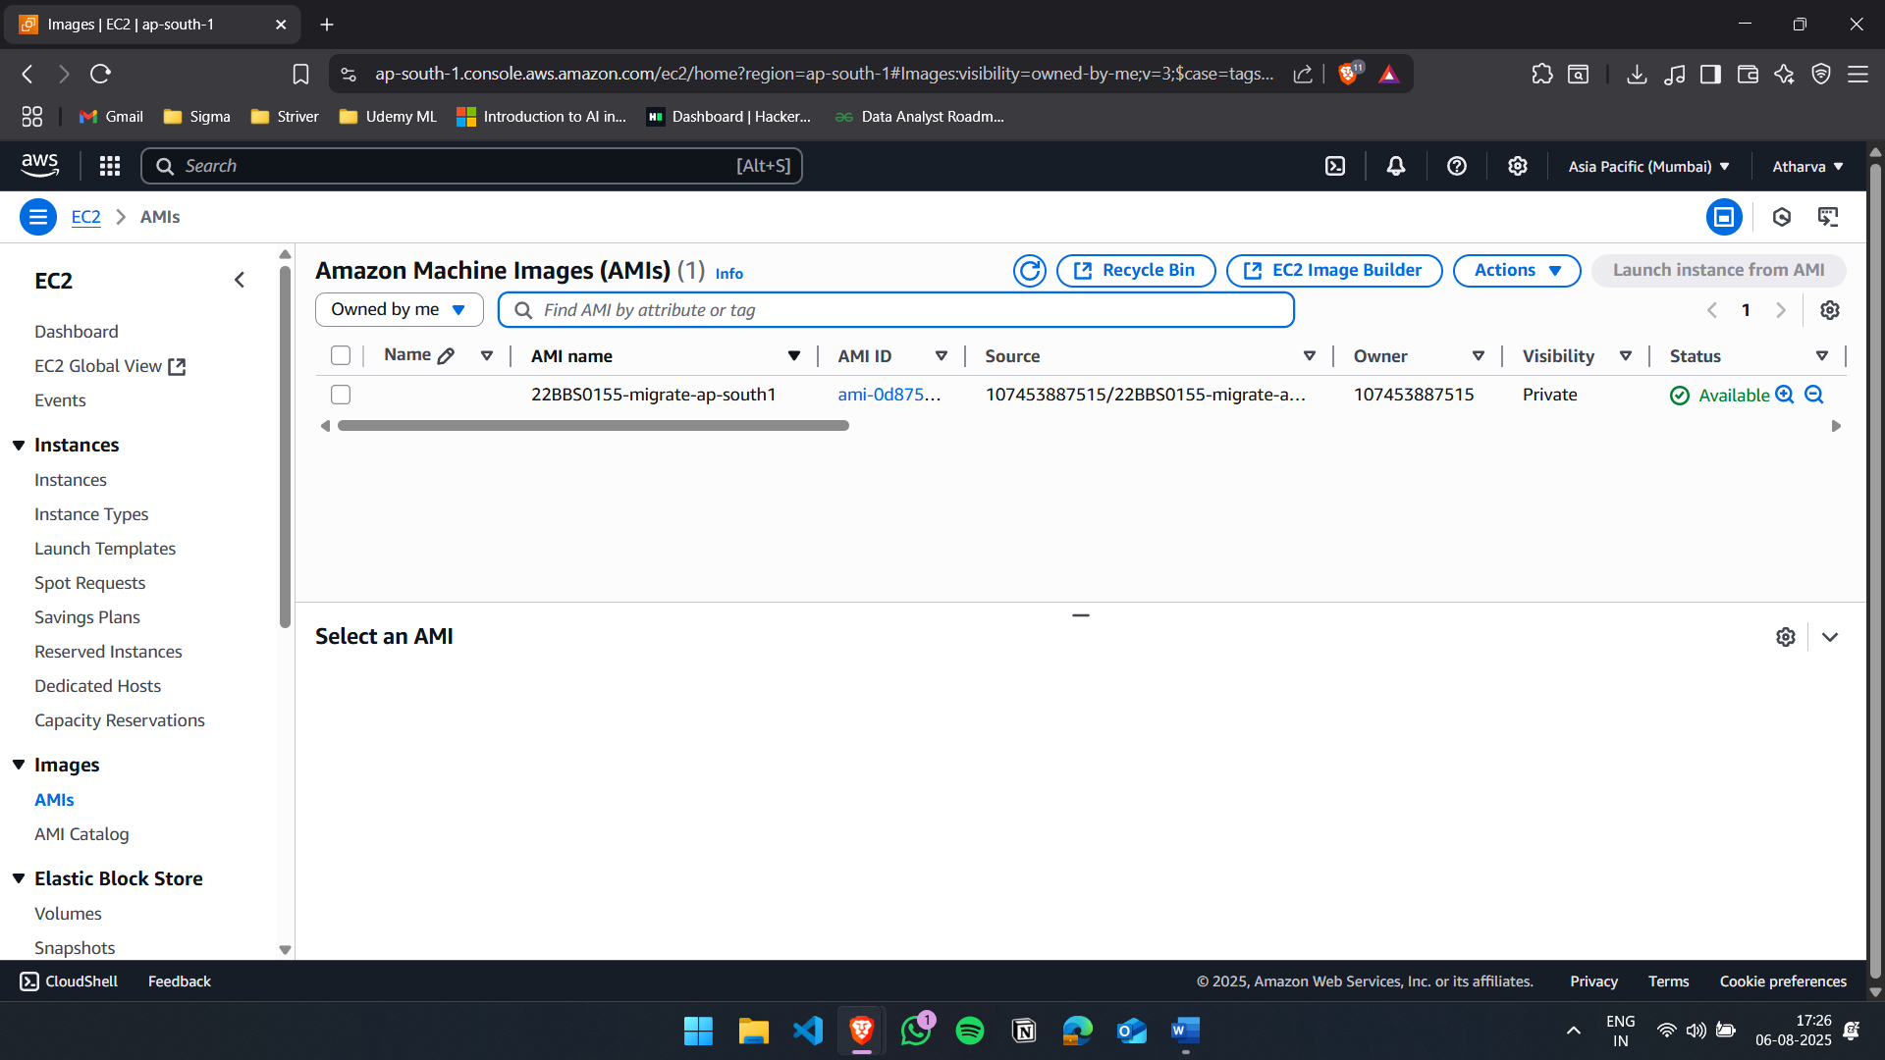

- Launch AMI Instance
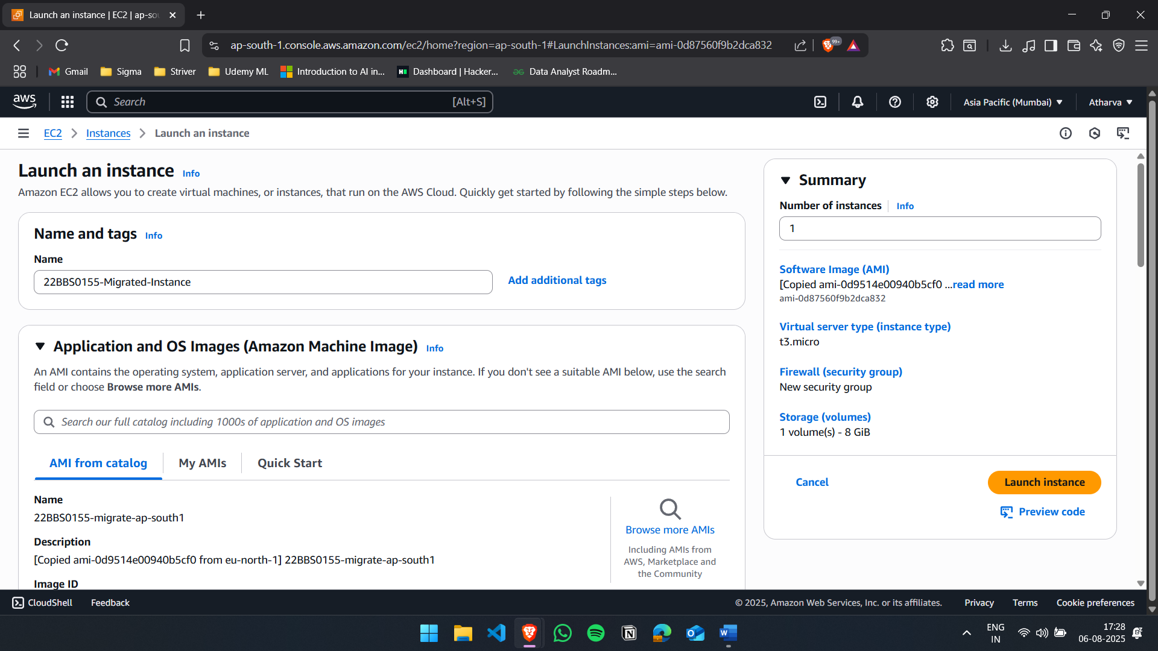

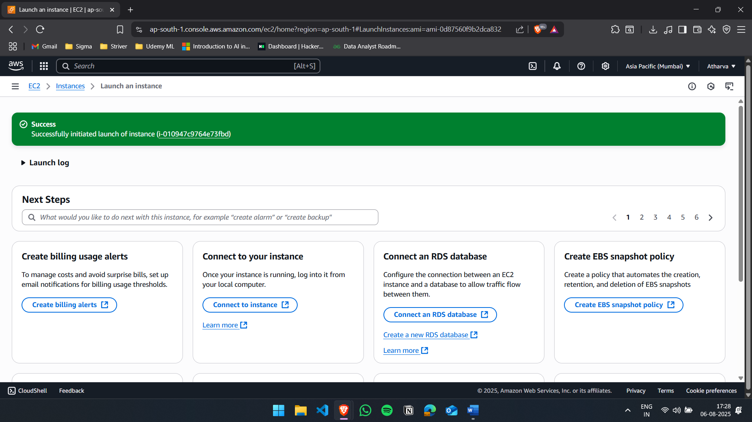
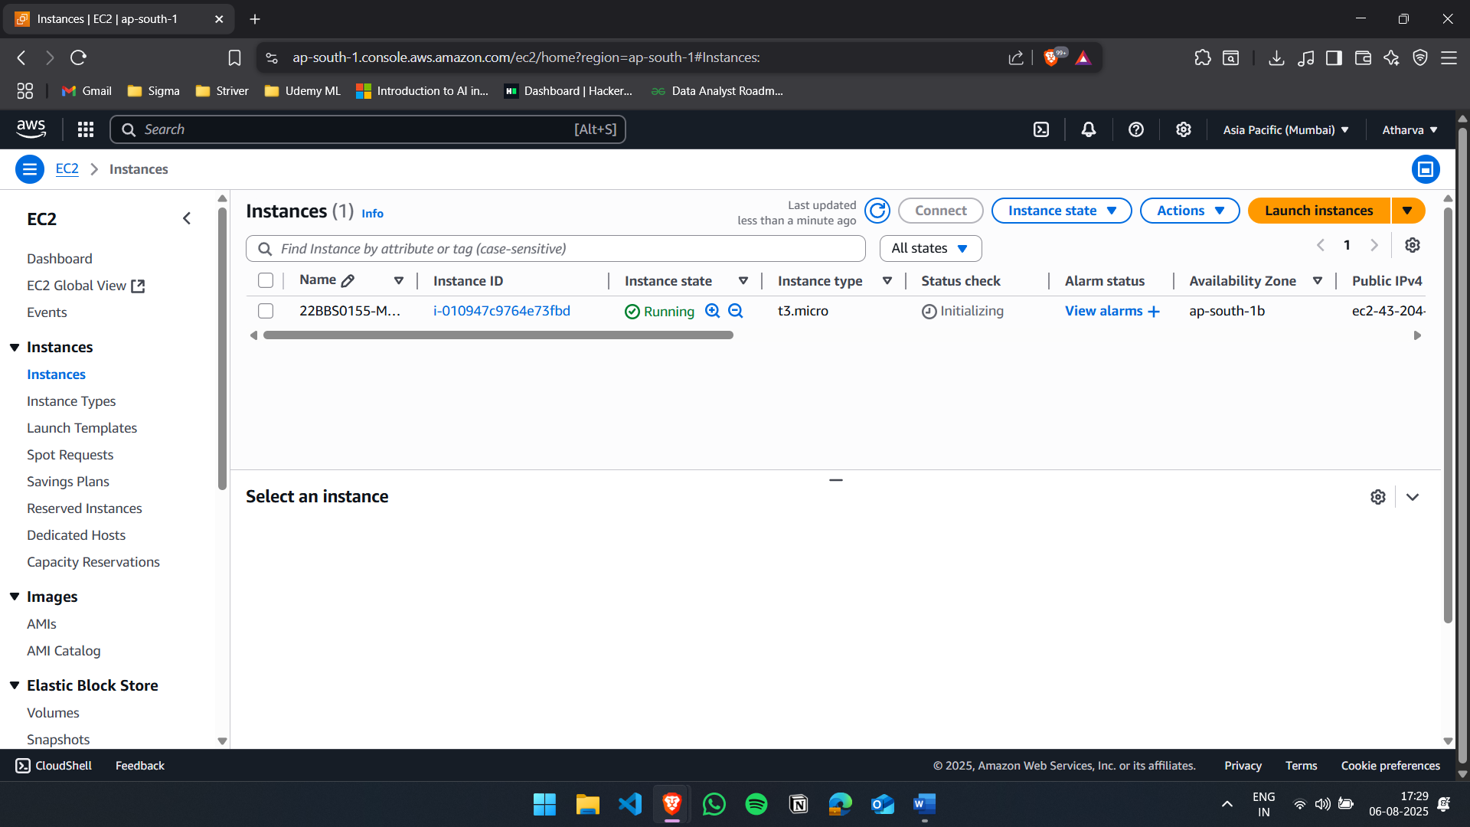

- Create another instance for My-SQL
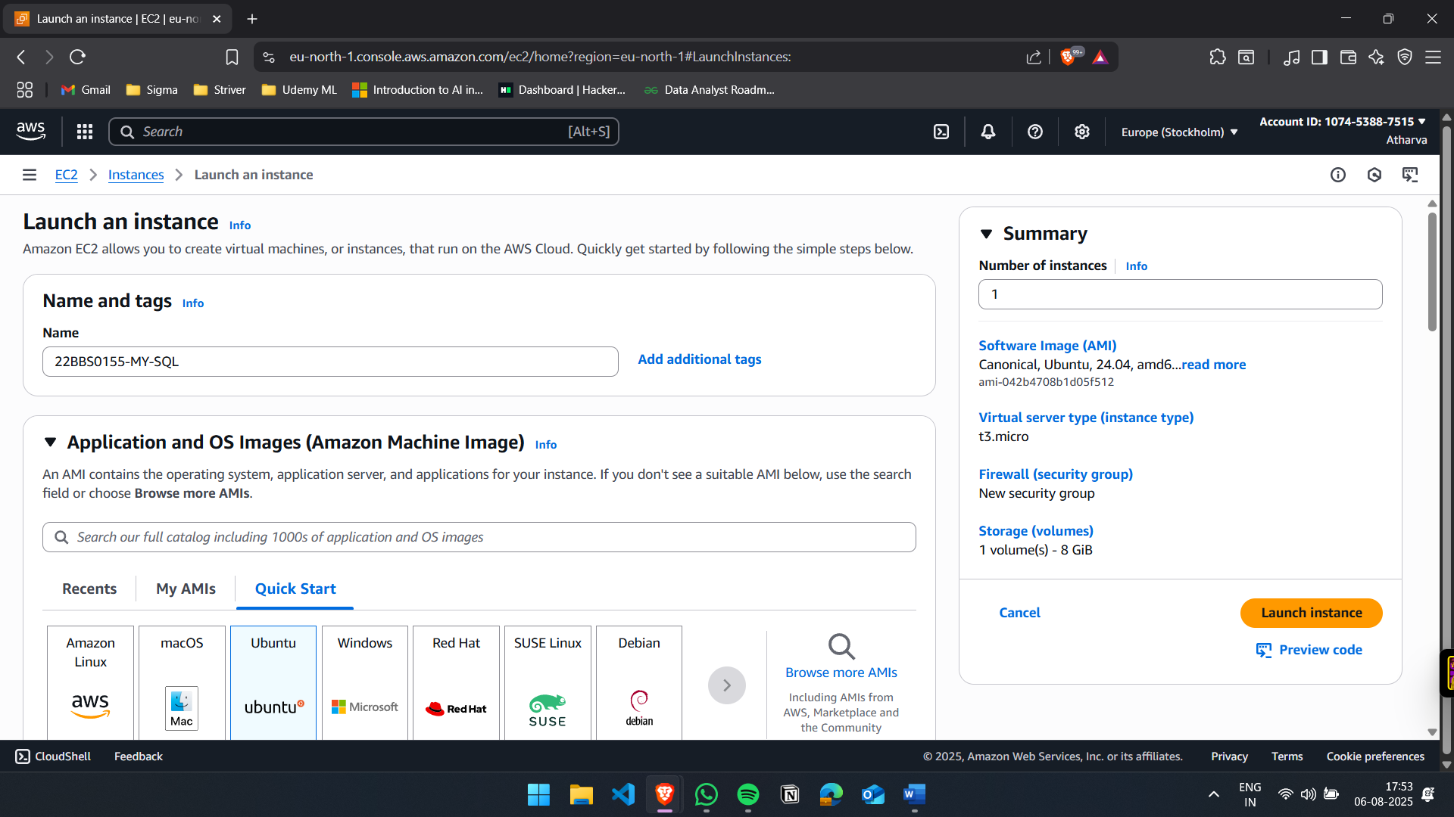

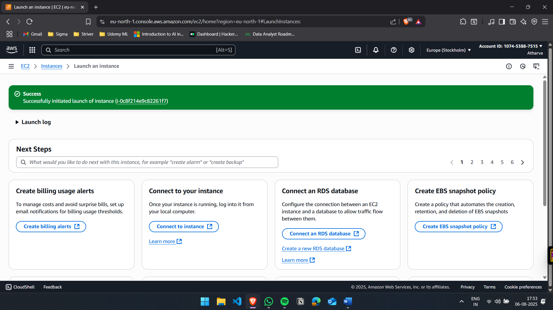

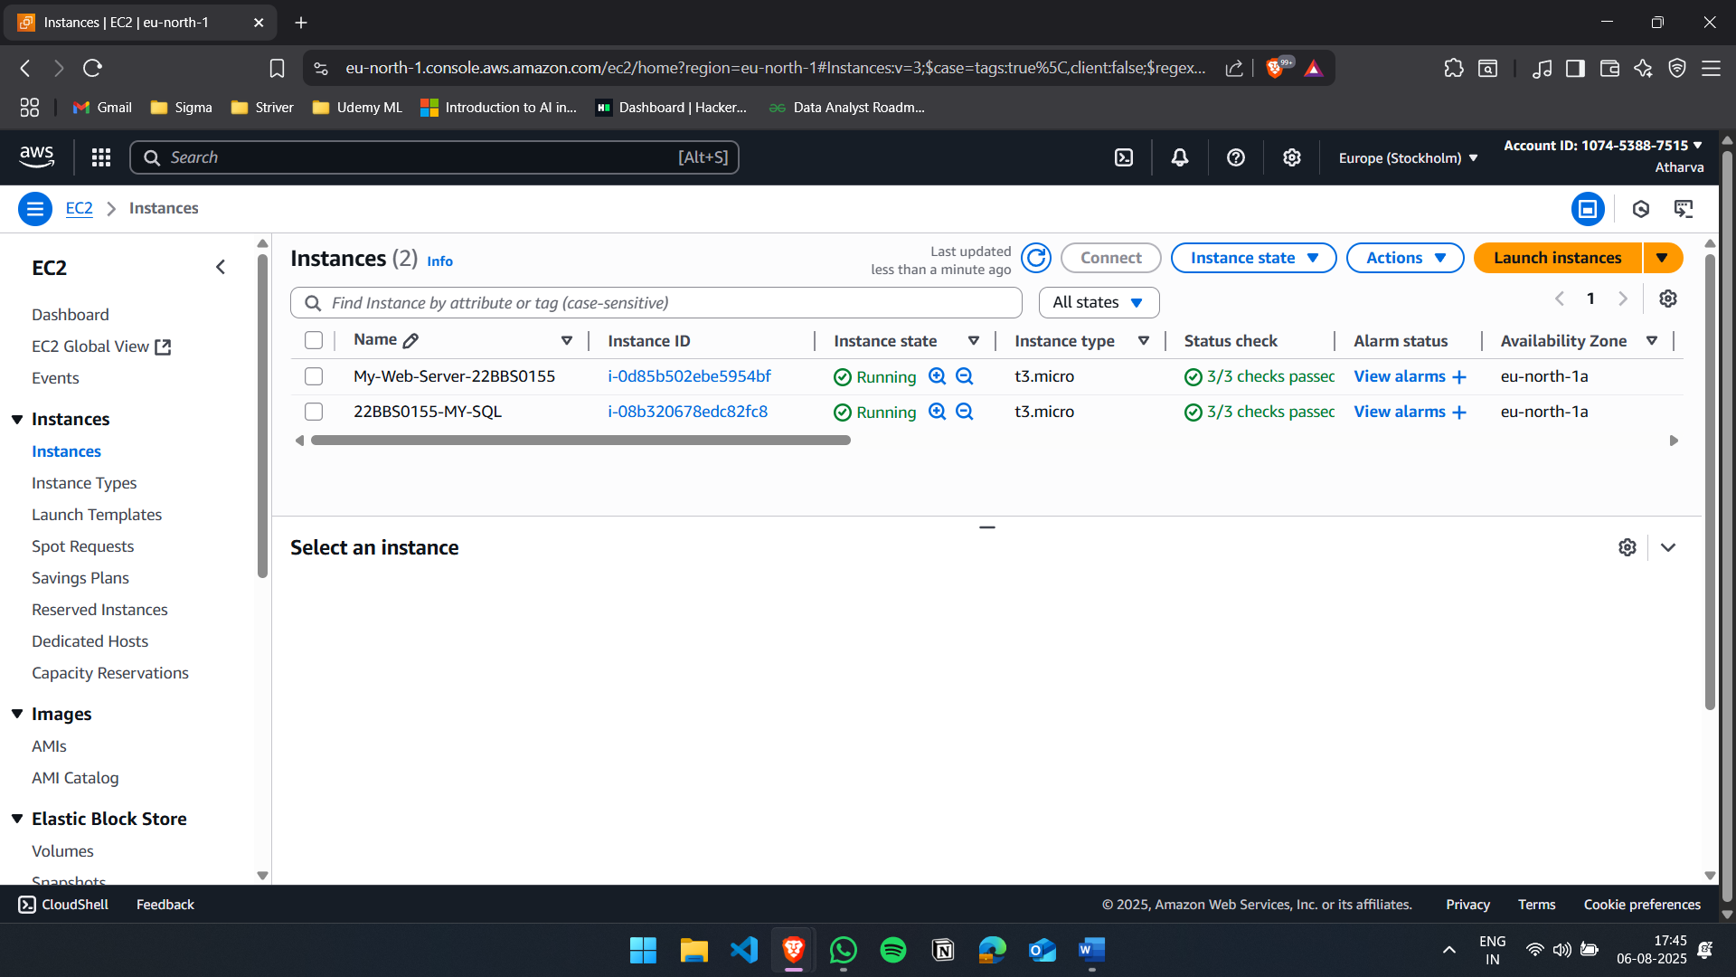

- Connect to the Instance
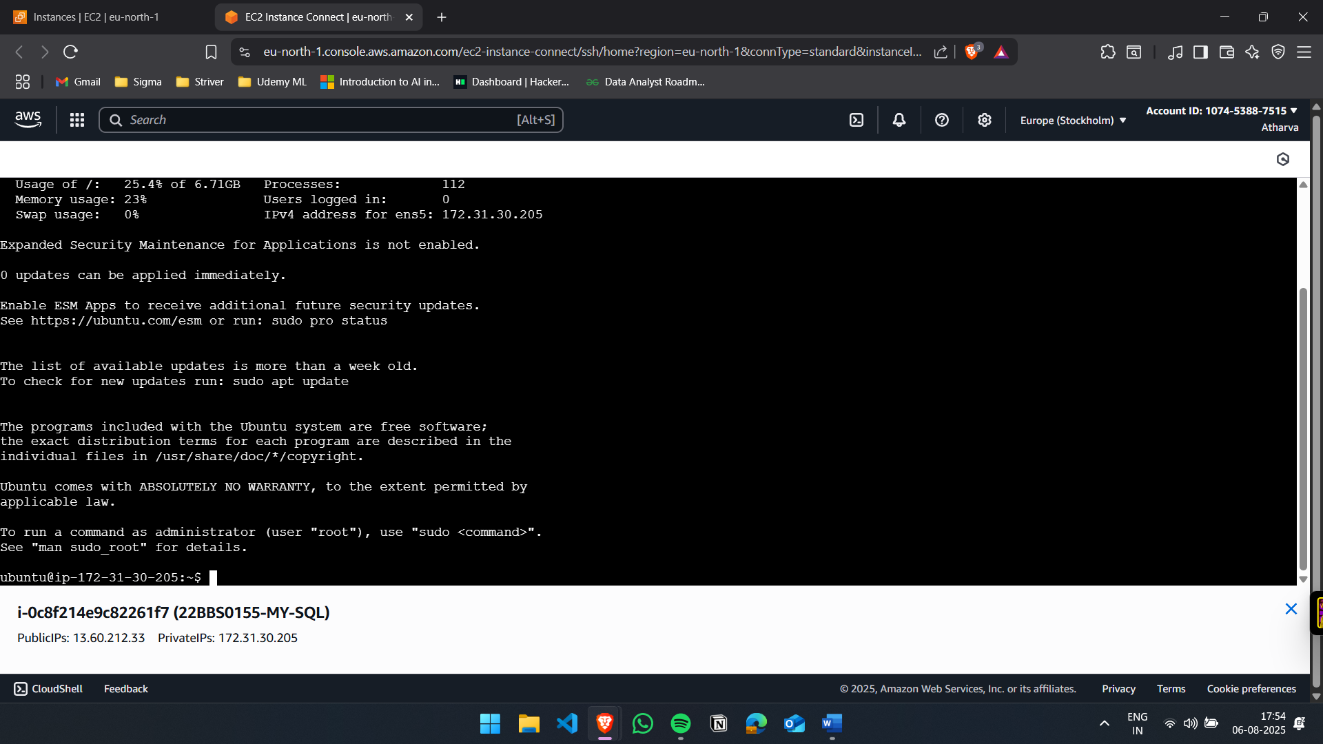

- Install and run MYSQL and perform operations
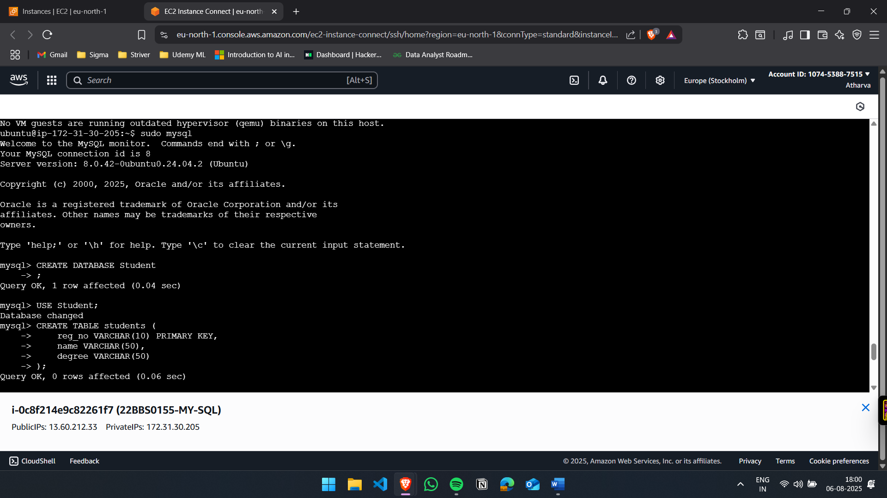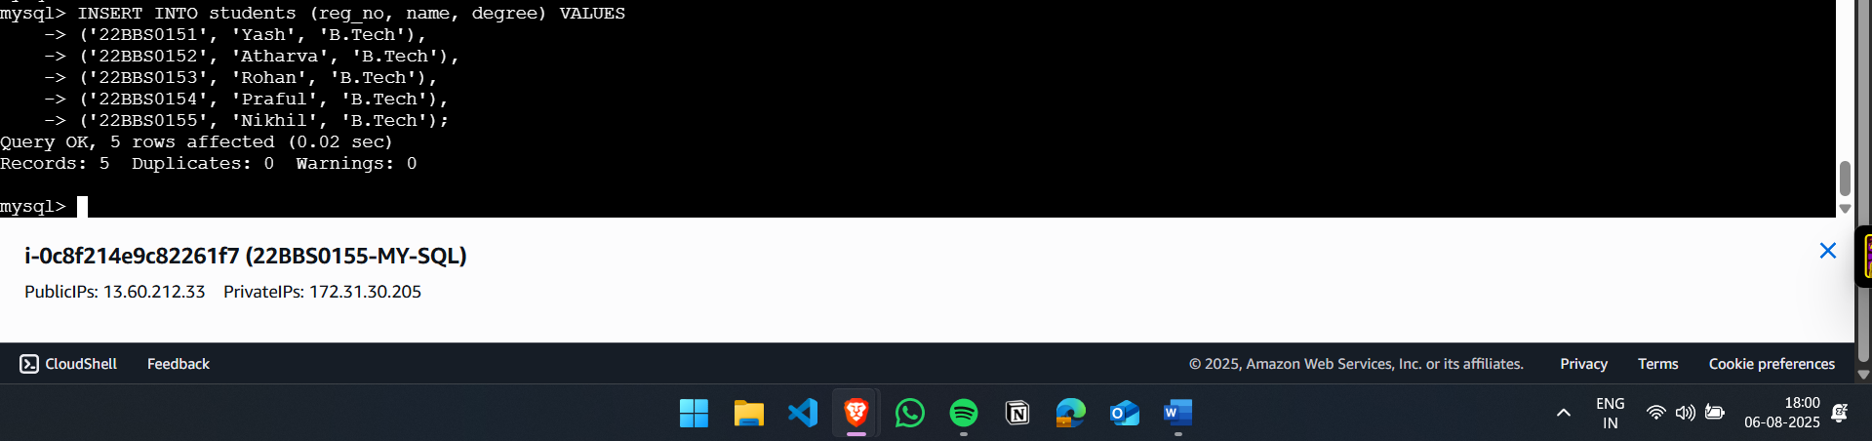

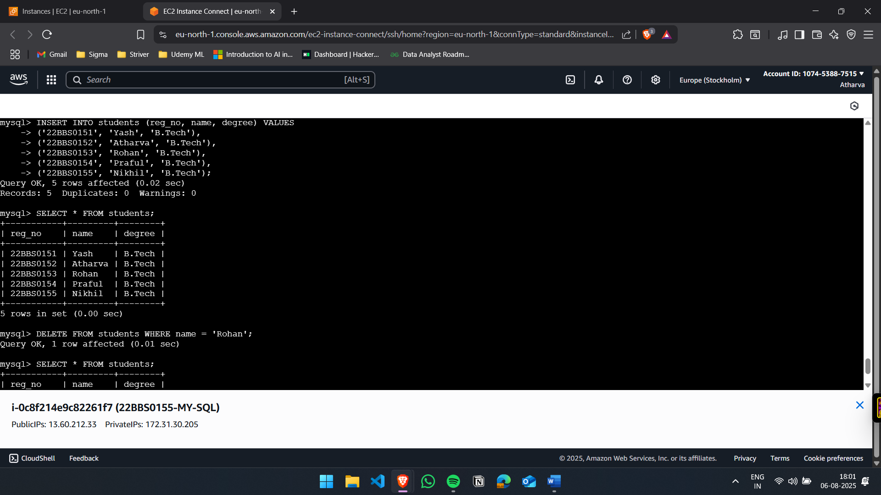

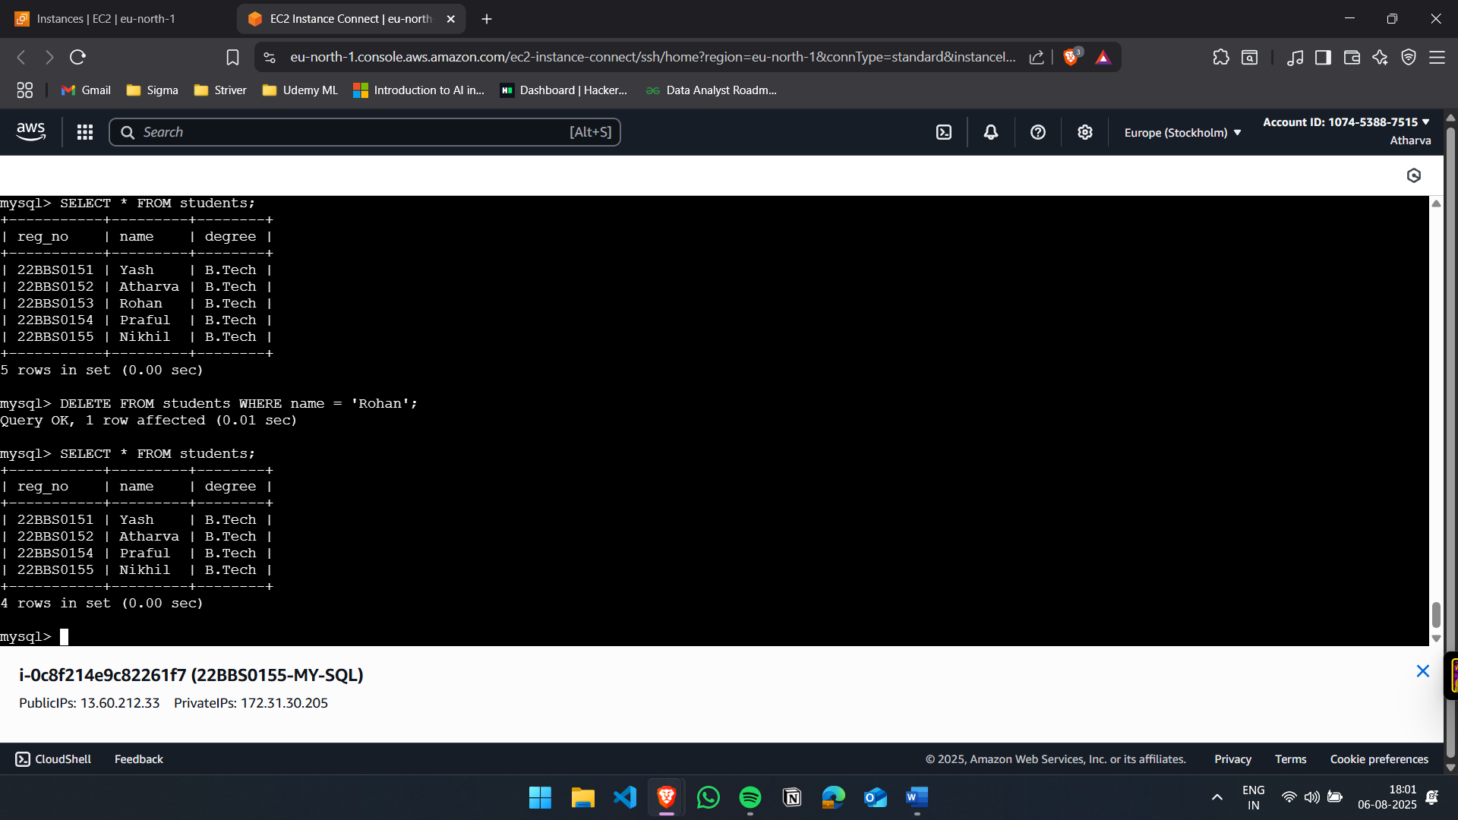

Q.2) Set up an S3 bucket in AWS, ensuring the name is globally unique. Upload your static website files (HTML, CSS, JavaScript, etc.) to this bucket. Enable static website hosting in the S3 bucket properties and configure the documents. Apply the necessary bucket policy to make your site publicly accessible. Also, enable versioning on the bucket to maintain previous versions of your website files.
Solution:
- Initial S3 Page:
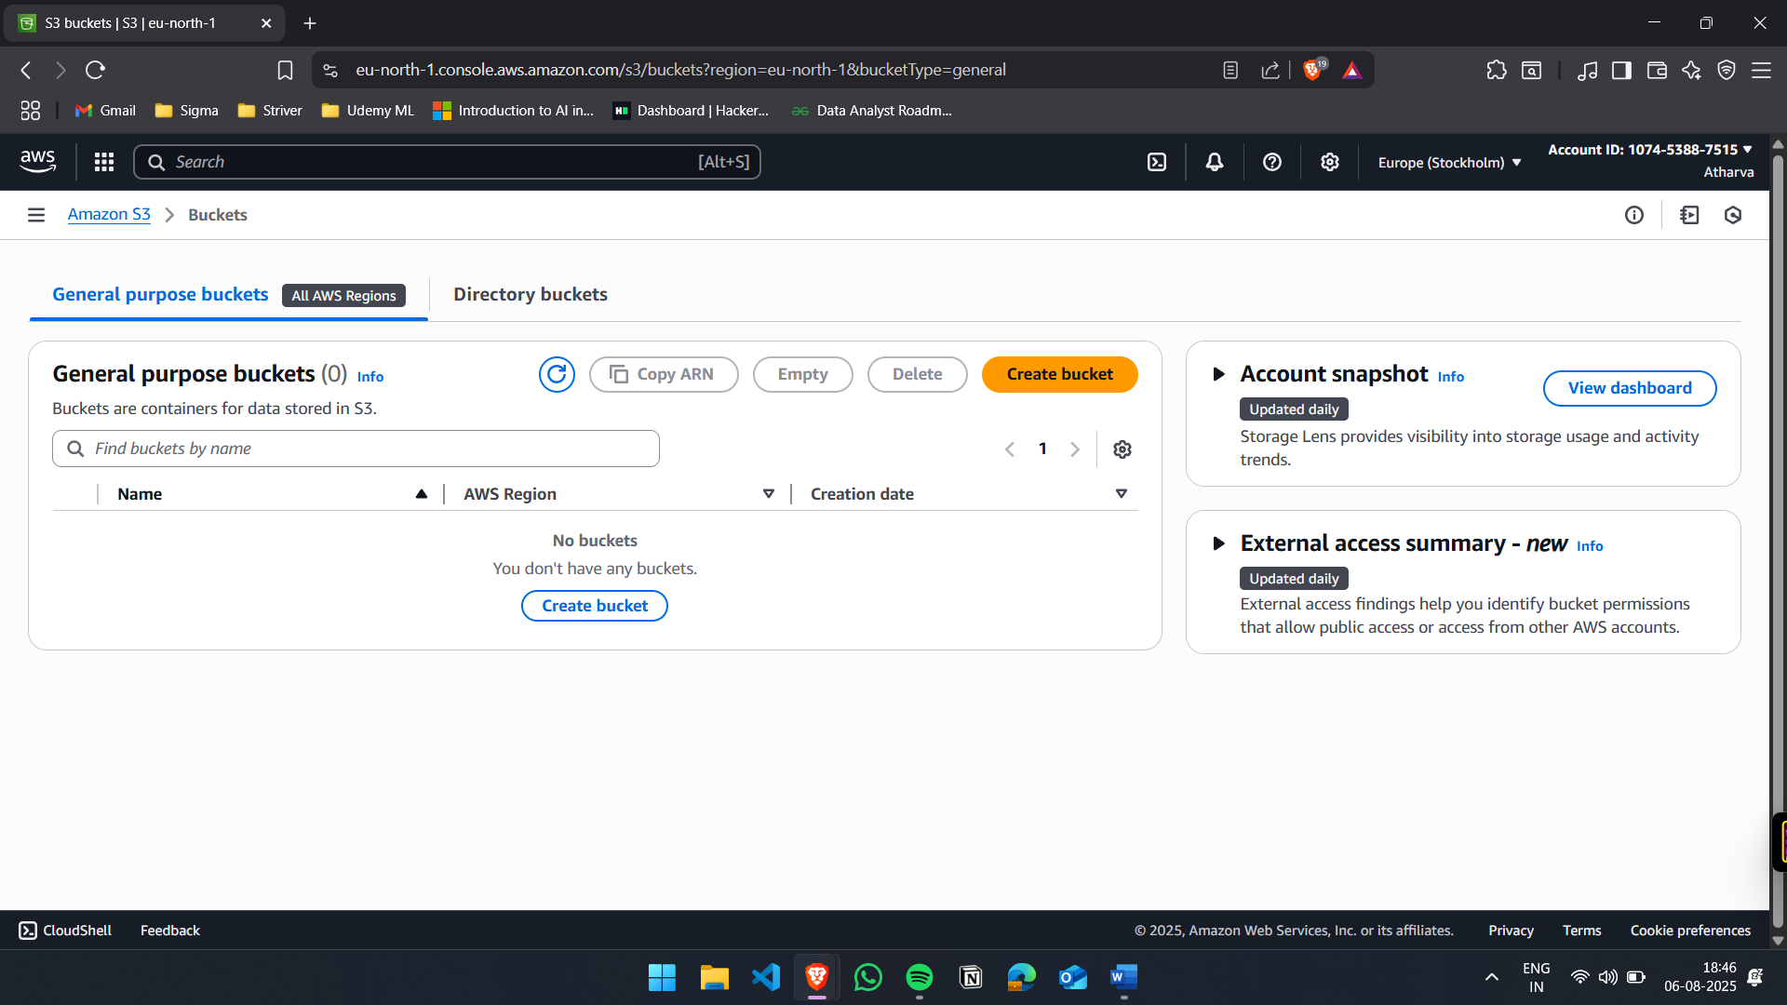

- Create S3 Bucket
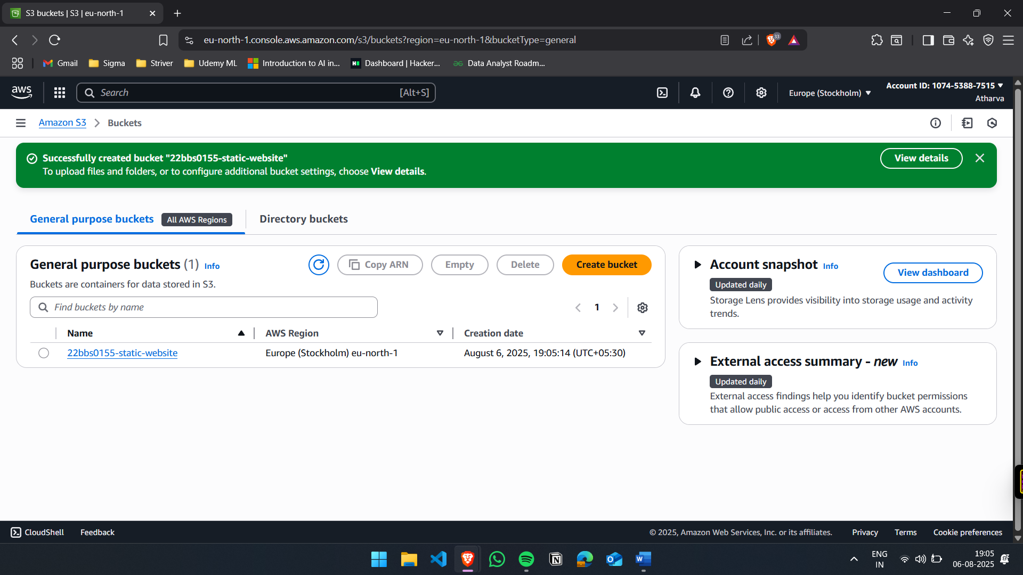

- Upload files
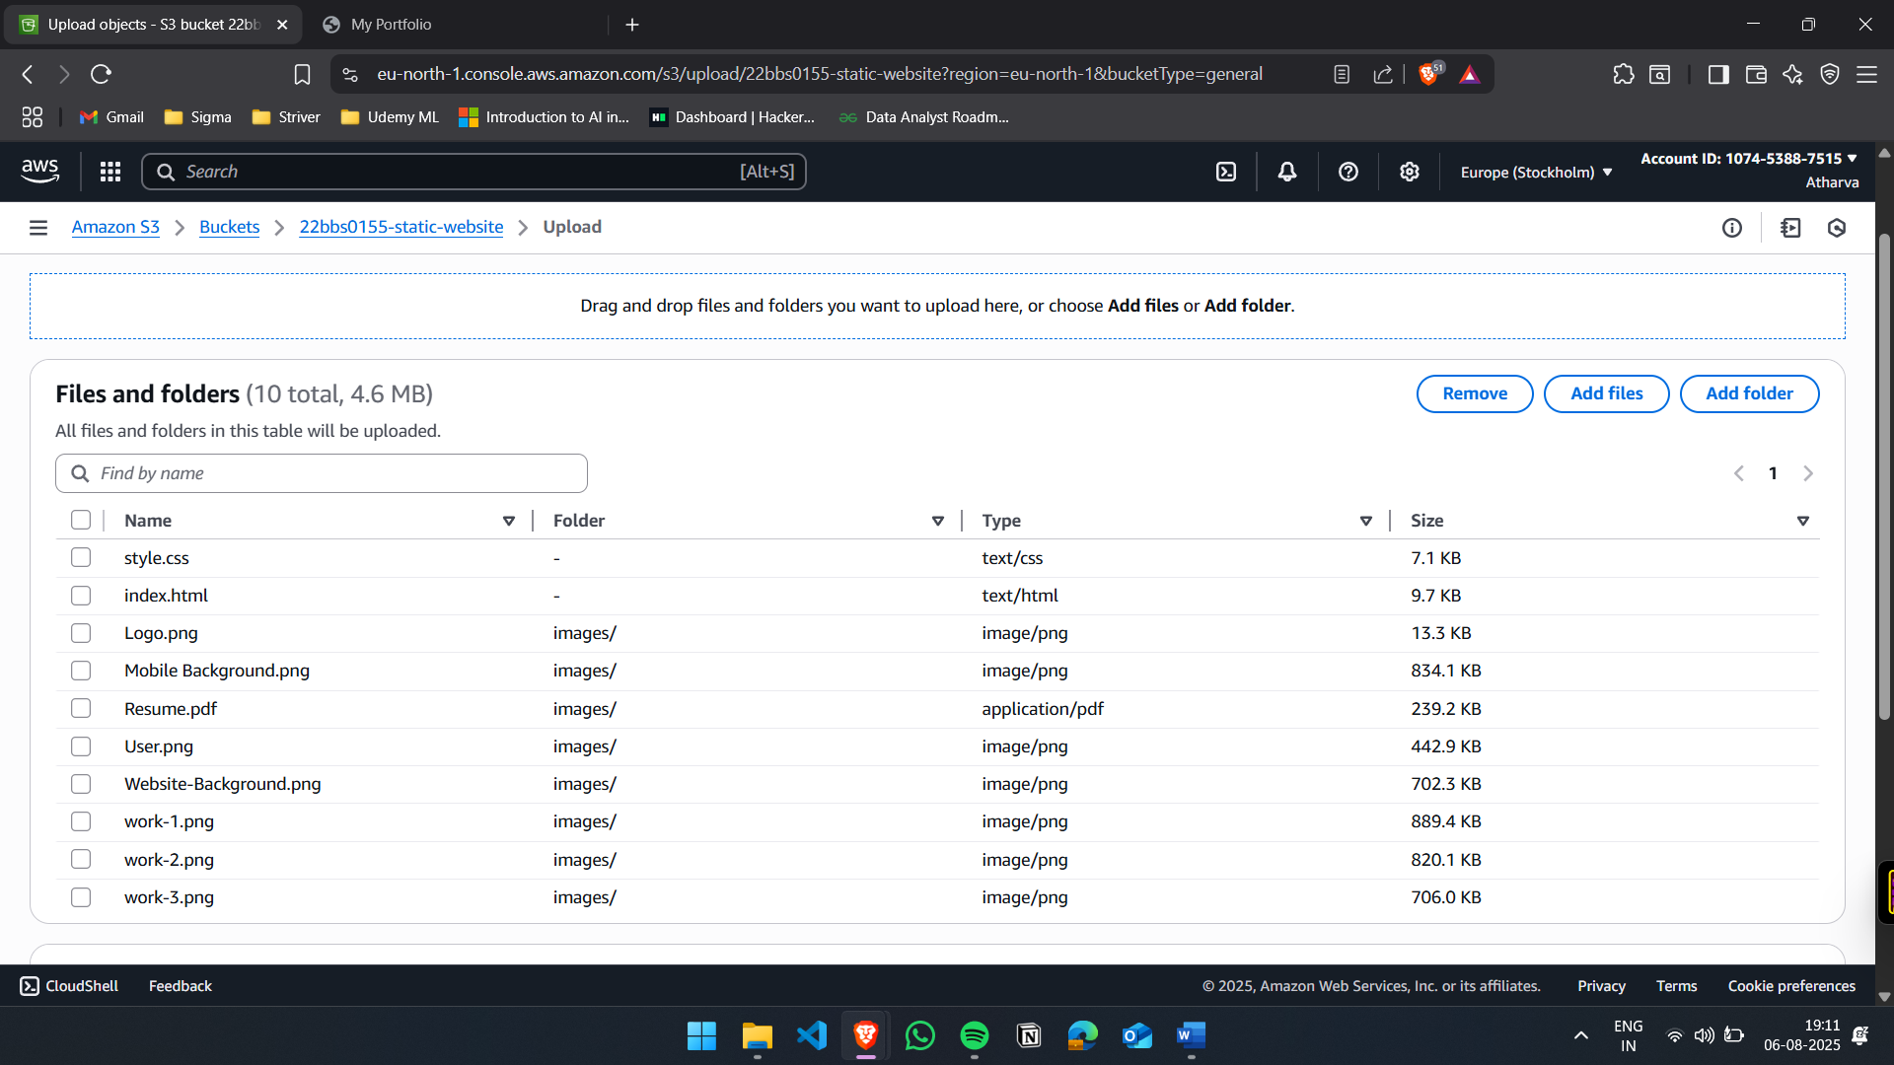

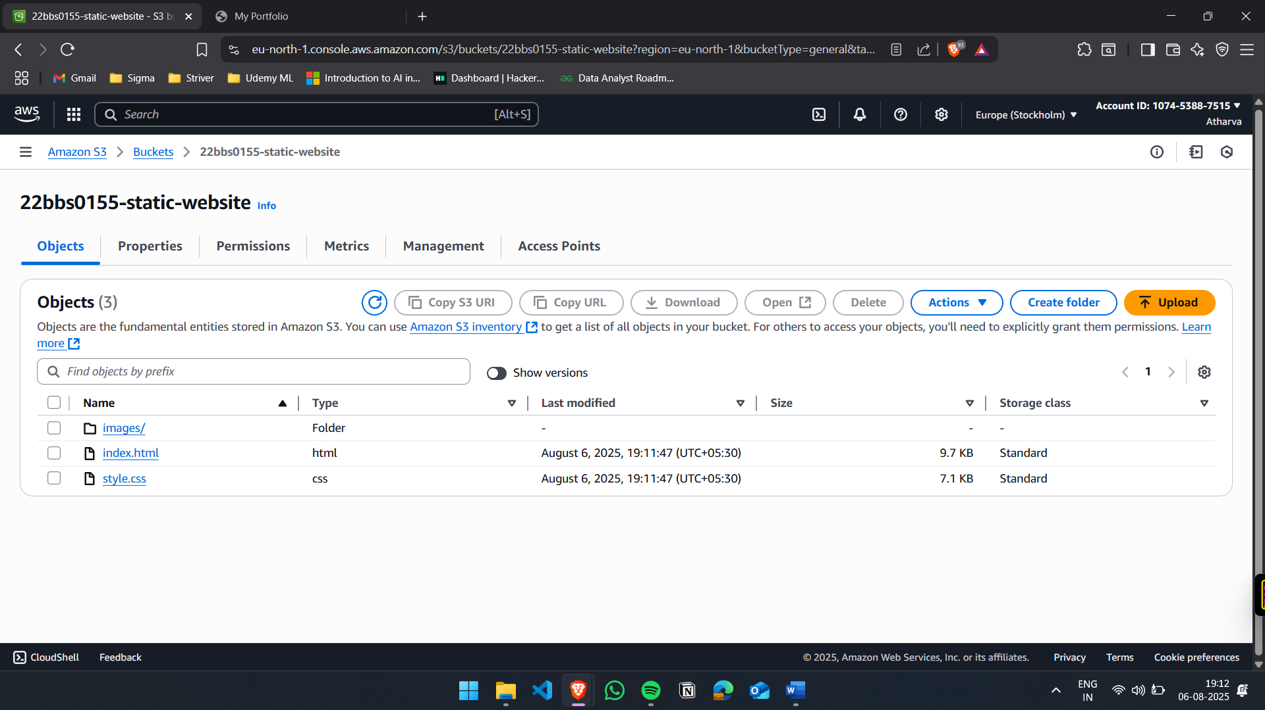

- Enable Static Website Hosting
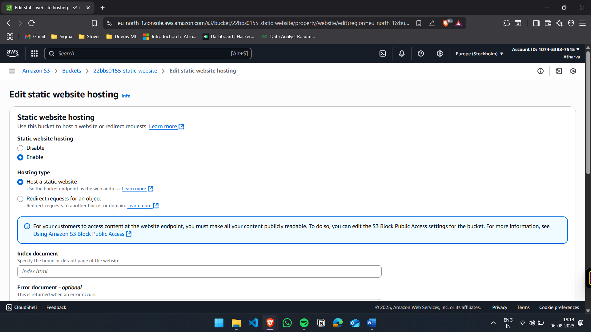

- Edit Bucket Policy:
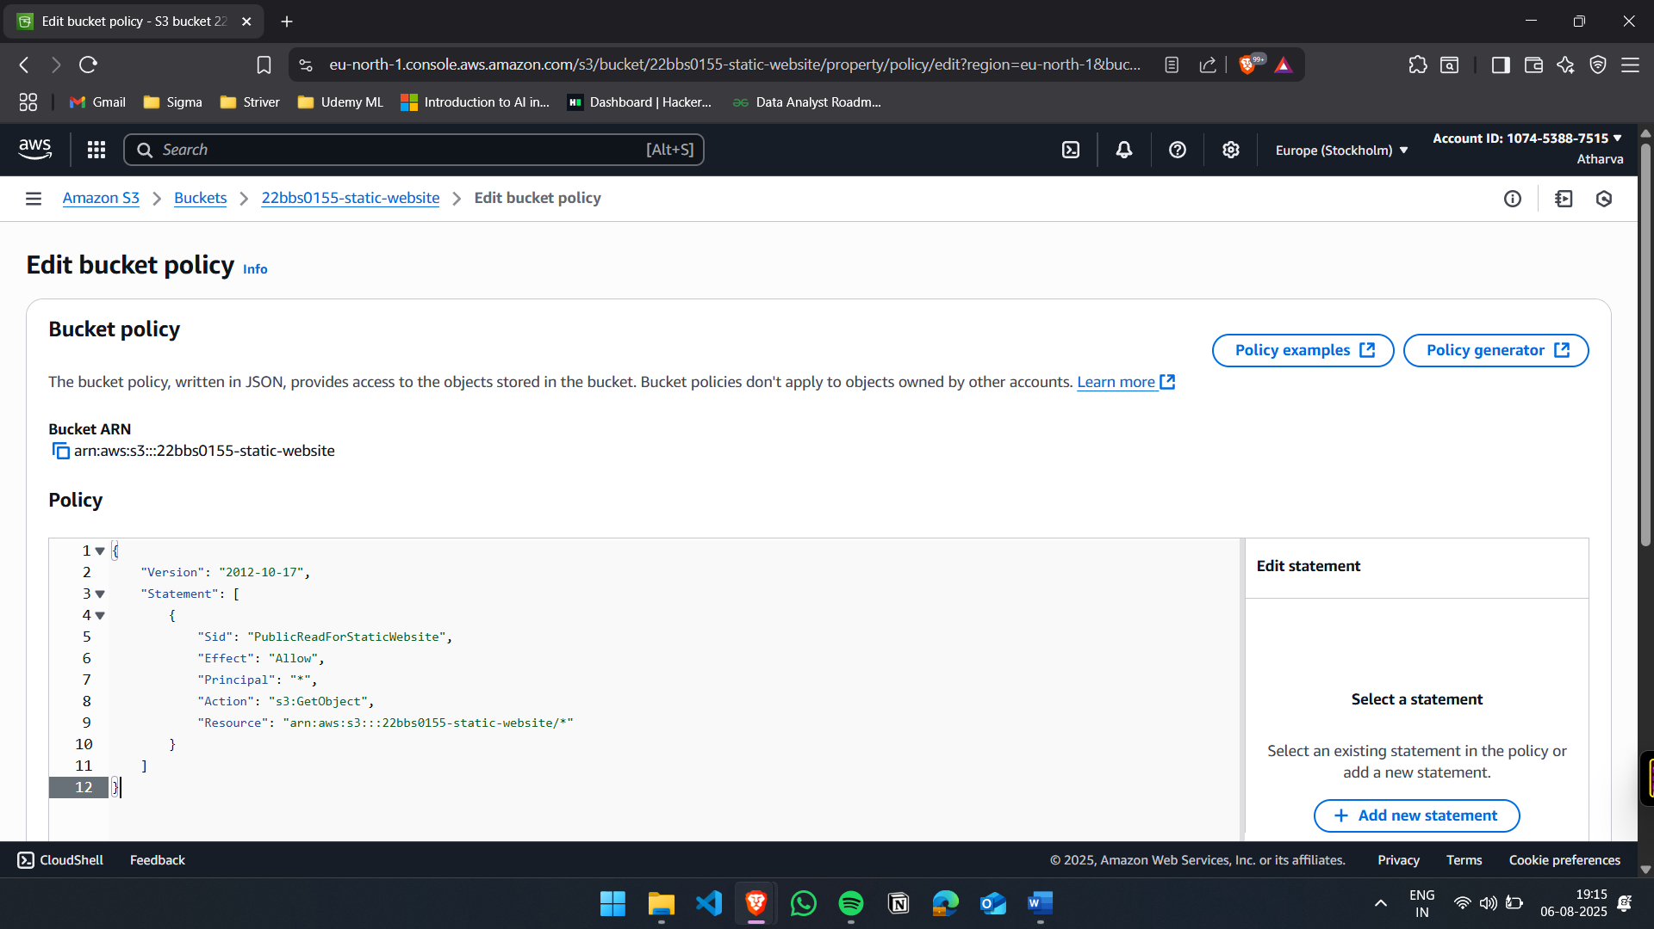

- Open the website
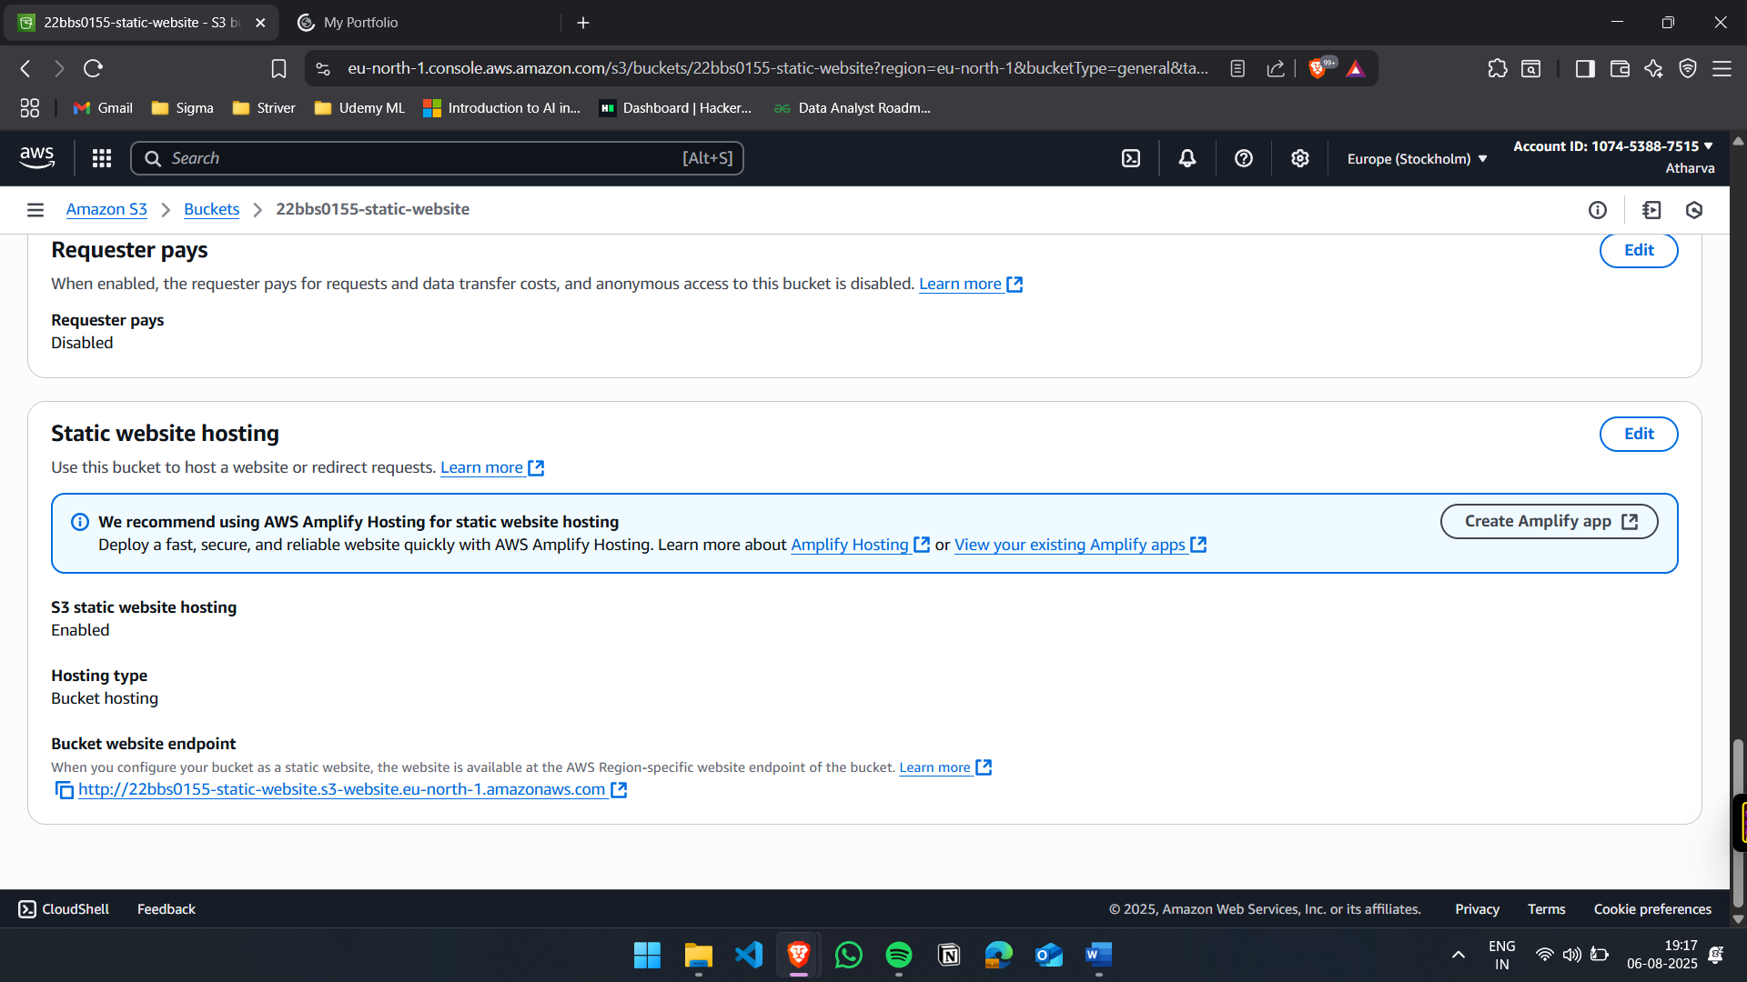
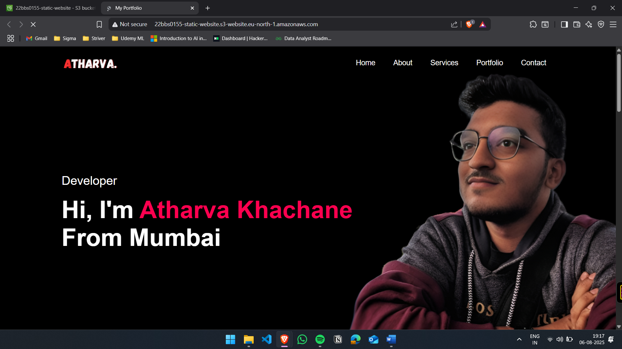

- Enabled Versioning
